THE SLATE
Gallia County Chapter of the Ohio Retired Teachers Assoc. May – June 2016
The Gallia County Retired Teachers met on June 9th, 2016 at First Baptist Church in Gallipolis, OH. The meeting was called to order and everyone was welcomed by President Ollie Paxton. The Pledge of Allegiance was led by Gail Belville and the blessing was given by Henry Dillon. Thirty-five members and five guests were present. After a lunch consisting of potluck dishes prepared by the members, the business portion of the meeting resumed at 12:40.
Marlene Hoffman gave a short history of how Katherine Williams was instrumental in the establishment of a scholarship fund by setting aside money in her will to be given to Gallia County Retired Teachers to provide scholarships for future teachers. The organization has always tried to be good stewards of this monetary donation and are continuously seeking ways to add to the scholarship fund to aid prospective teachers well into the future. Donations for the scholarship fund are collected at each meeting.
Scholarship recipients were introduced by the scholarship committee consisting of Karen Cornell, Nancy Hood, and Letty Willis as follows: (1) South Gallia High School graduate Tristan Davis will be attending Marshall University and plans to study secondary education. (2) River Valley graduate Peyton Browning will be attending Ohio University and plans to become a speech pathologist. (3) Gallia Academy graduate Jordan Walker will be attending the University of Rio Grande with plans to major in preschool and special education.
Newly retired teacher LouAnn Shawver was congratulated and welcomed by the membership. First time attendees made welome by the group included retiree Letty Willis and guests Beth Hollanbaugh and Lorna Nomina.
May/June Birthdays were: Lou Ann Shawver, Lorna Nomina, Lynn Arnott, Jean Meek, and Irene Clark. Marlene Hoffman led the group in singing “Happy Birthday”.
A “thinking of you” card was sent to Doug and Carol Norris. Please remember the families of Tina Russell and Katherine Donnally.
President Paxton thanked Nancy Hood and Kay Adkins for decorating the tables and Lois Carter for making the reservations with First Baptist Church for the meeting.
Donations were accepted for our service project Snack Pack program and for the scholarship fund.
Minutes from the April 2016 meeting were included in the last issue of The Slate. Debbie Rhodes made a motion to approve the minutes. This was seconded by Beth James. Motion passed.
The treasurer’s report was given by Jack James as follows:
Checking account: $410.96; Annuity: $16,400.71; Scholarship Savings: $3,113.49; and Scholarship CD’s: $6,411.12. A motion to approve the treasurer’s report was made by Debbie Rhodes. This was seconded by Gail Belville. Motion passed. Treasurer James stated that the membership needs to be considering ways to invest monies when the scholarship CD becomes mature in November 2016.
Committee reports: Legislative – None; Community Participation & Volunteer Hours – Karen Cornell asked members to continue to log their volunteer hours; Informative & Protective Services – None; Membership – One new life member added today; Pre-Retirement Planning – None; Phone Tree – Julie Dragoo reported that it has been updated; Scholarship – introduction of scholarship recipients by committee members; Webmaster – None; and, Public Relations- Donna DeWitt reviewed articles in the recent Spring 2016 Issue of ORTA The Voice of Ohio’s Retired Teachers Quarterly. Gallia County Retired Teachers Association was recognized twice in the issue. We were recognized for our donation of a basket of Gallia County items to the Athens Habitat for Humanity’s annual Taste of Southeastern Ohio fundraiser held at Hocking College in Nelsonville. We were also recognized for our number of volunteer hours. We were among the top chapters who reported volunteer hours in 2015 with 10,144 hours. Carol Remington, our ORTA President in her June letter to members, challenged everyone to “bring one”. She suggested offering an incentive to a teacher who brings in the most new members. She also recommended two books for good summer reading: (1) Breaking Wild, which suggests that “Life is a risk-if we protect ourselves too much, nothing will happen-nothing at all.” (2) The Wright Brothers by David McCullough, which reminds us that Ohio is the birth state of aviation, how much has been accomplished in the past 115 years in aviation, and that hard work pays off! According to Remington, the Wright’s younger daughter was an educator and she says that the Wright’s took so many risks! ORTA members are invited to register for a monthly e-mail newsletter from ORTA’s investment firm UBS. Register at allan.covert@ubs.com. As an ORTA member, you are also provided a free investment analysis upon request. A new designated email address has been set up to receive items for publication at: news@orta.org. Donna will be submitting our press releases for publication. Donna also asked members to keep their email and mailing addresses current in order to receive The Slate and meeting reminders.
Old Business – (1) President Paxton reminded members to check their renewal date on teaching licenses. She reminded everyone that the law changed in 2015 and you must have a background check every five years, even if you have a permanent license or ODE will begin revoking the licenses, including permanent licenses. If you have lived outside of Ohio within the last five years, you will also need to have a BCI check. (2) President-Elect position needs to be filled A.S.A.P. Contact President Ollie Paxton if interested. (3) A special collection will be taken for Habitat for Humanity at the August meeting. Donna DeWitt will be accepting donations of Gallia County items for our basket donation to Habitat for Humanity in the fall. (4) Remember to bring raffle items to donate for the raffle at each meeting to help raise funds to defer the cost of mailing the newsletter.
New Business – (1) A letter from Kristin Burnett was read. She requested a donation to enable her to attend National History day in Maryland. A discussion was held about donating to an individual. After discussion, Marlene Hoffman made a motion to collect a donation from the members present and GC-ORTA add to it to make $100.00. Motion was seconded by Ellis English. Motion passed. A total of $171.00 was collected, so Marlene rescinded her previous motion and amended the new motion to donate $29.00 from GC-ORTA funds to bring the total donation to $200.00. The amended motion was seconded by Ellis English. The amended motion passed. Treasurer James will send Kristin Burnett a $200 donation for her trip to Maryland for National History Day.
Next meeting - Thursday, August 11, 2016 at noon at Bossard Library. The speakers will be someone from the library staff and Don Baker from ORTA. The menu will be catered but the menu, cost, and caterer is unknown at this time. Reminder: if you make a reservation to attend and are unable to for any reason, you are still required to pay for your meal as GC-ORTA is responsible for paying for the number of meals that are ordered.
Raffle netted $110.00. Winners were: Kay Adkins, Ollie Paxton, Lorna Nomina, Lois Carter, Vicky Rowe, Dorothy Ruff, Irene Clark, Doris Lanham, Lou Ann Shawver, Patty Young, Debbie North, Debbie Rhodes, Gail Bellville, Lynn Arnott, Donna DeWitt, Pat Dillon, and Gene Spurlock. Thanks to Gail Belville for taking care of the raffle tickets.
Lois Carter made the motion to adjourn. This was seconded by Gail Belville. Motion passed. The meeting was adjourned at 1:30 p.m.
Members and guests attending were: Lois Carter, Kay Adkins, Julie Dragoo, Donna DeWitt, Gene & Sara Spurlock, Dorothy Ruff, Jack & Beth James, Ollie Paxton, Nancy Hood, Gail Belville, Karen Cornell, Vicky Rowe, Ellis English, Henry and Pat Dillon, Lou Ann Shawver, Debbie Rhodes, Debbie North, Marlene Hoffman, Lynn Arnott, Lorna Nomina, Doris Lanham, Letty Willis, Sheryl Fallon, Beth Hollanbaugh, Christa Walker, Jordan Walker, Jim & Irene Clark, Jean Meek, Patricia Young, Bob & Vickie Powell, Tristan Davis, Dafney Davis, Brent Saunders, Chris Williams, and Peyton Browning.
Pictured below: Scholarship winners, New retiree LouAnn Shawver, and Scholarship Committee.
Remainder of 2016 Gallia County Retired Teachers Meeting Schedule
DATE | TIME | LOCATION | MENU | PROGRAM
August 11 | Noon | Bossard Library | Menu ???  Cost ??? | Library staff/Don Baker, ORTA
October 13 | Noon | Nazarene Church | Menu ????  Cost ???? | Melvin Biars of Floral Fashions
December 1 | Noon | Vinton Baptist Church | Menu: Ham loaf, potato, veg,, drink, & dessert  Cost: $12 - $15 ??? | Christmas Songs and Readings and Fundraising Auction
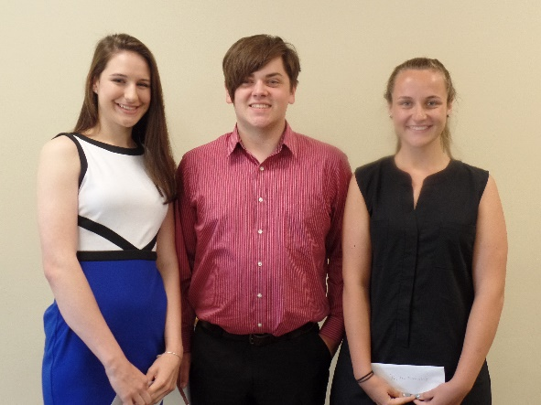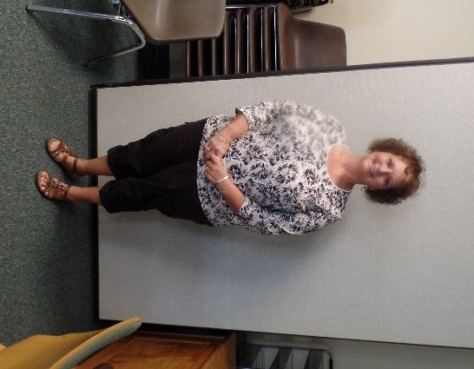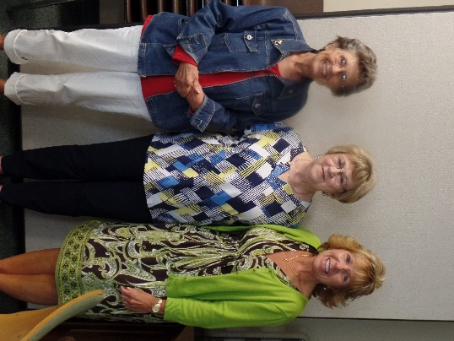
THE SLATE
P.O. Box 121
Vinton, OH 45686

Name__________________________________________________________
Address _______________________________________________________
Email Address __________________________________________________
Telephone # ____________________ Cell phone # _______________
_____ GCRTA – Annual Dues $ 8.00
_____Lifetime – Dues $ 50.00
_____ORTA – Annual Dues $ 30.00
_____Lifetime Membership Dues $500.00
TOTAL $______
Make checks payable to: GRTA for the total amount. GRTA will forward to ORTA.
Memberships can be mailed to the Treasurer: Jack James at 12762 St. Rt. 141 Patriot, OH 45658
ORTA – Ohio Retired Teachers Association has been helping teachers since 1947.

